**Question 1**

1. Create a blank file named "myfile"

2. Open "myfile" in vi editor

3. Write your name, address, email id, phone number and blood group in 5 different lines

4. Build one single expression to see the line with your name and blood group in myfile

**Answer**

Logged in as root

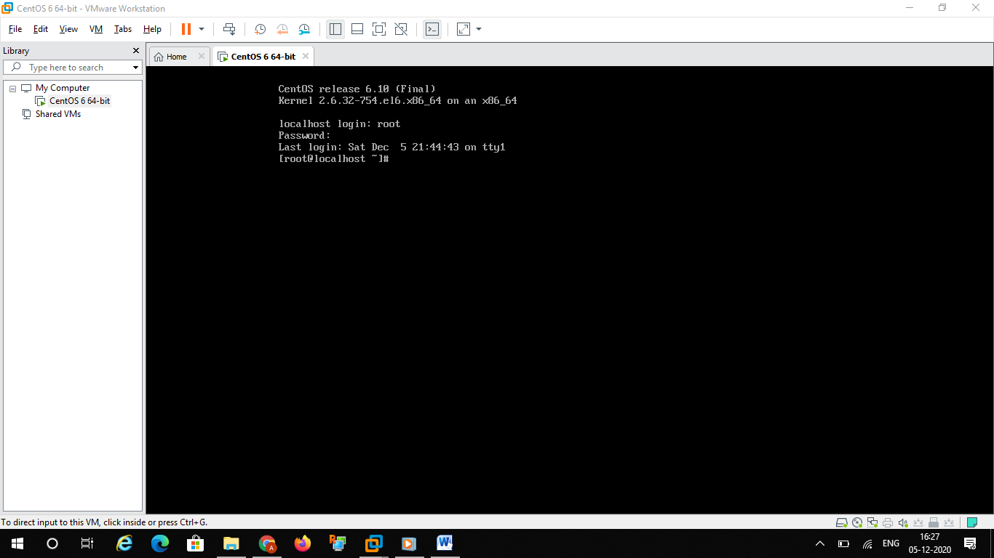

Step 1 :

Created blank file using touch command

Touch myfile

and after that used ls command to list file.

Then used cat command to see inside the file myfile

Output is as below

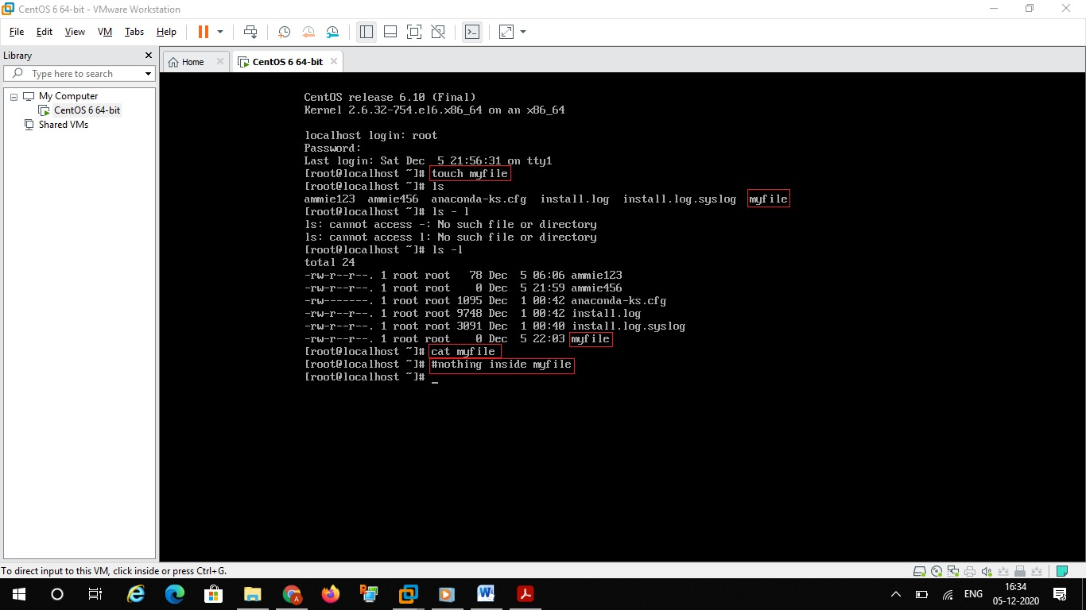

Step 2 :

Opening myfile using vi editor



After opening file ..pressed ‘i’ to get into insert mode

Step 3 :

Then inserted 5 rows as below

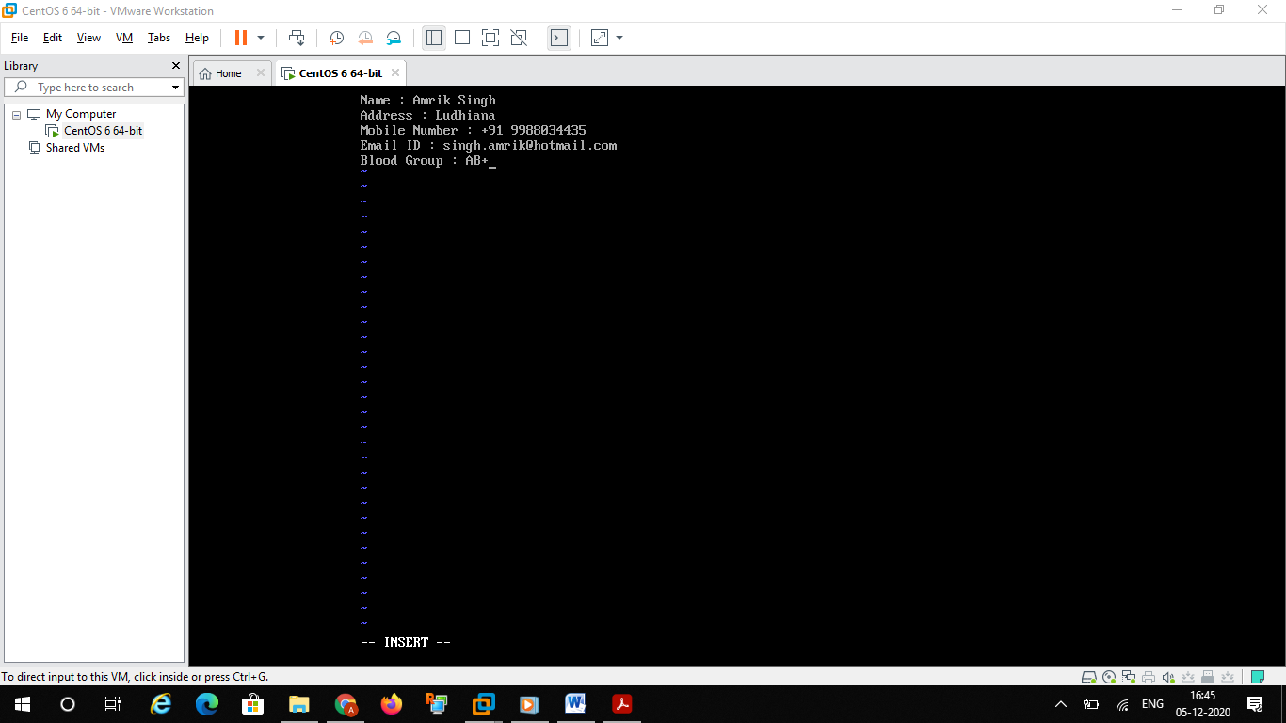

After that pressed ESC button

Then pressed :wq

After saving myfile is having the below data in the lines

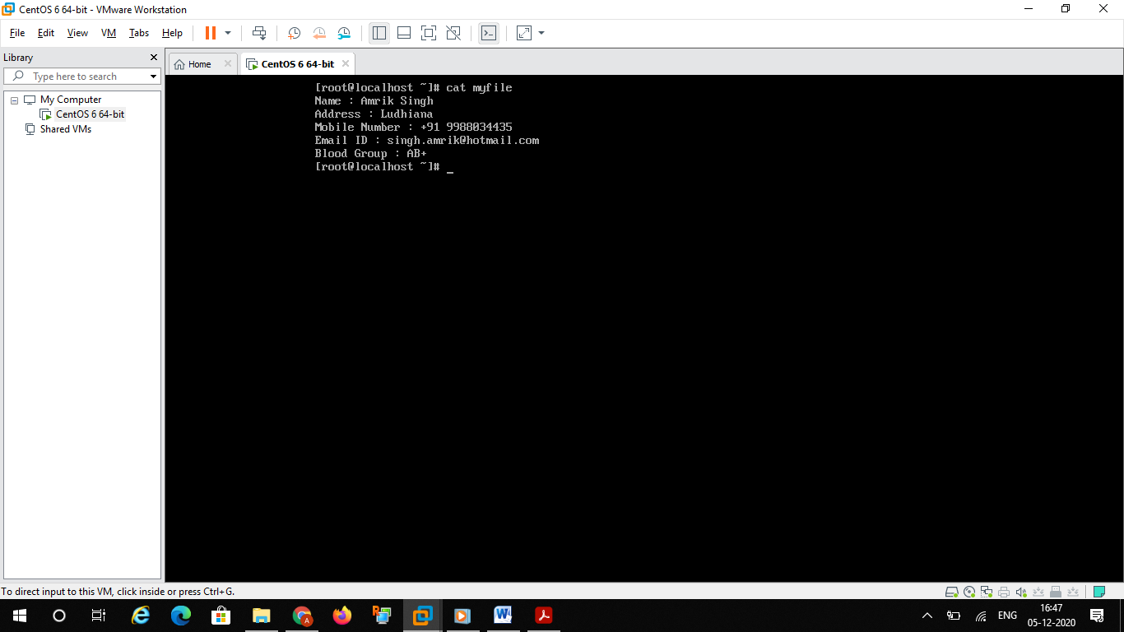

Step 4:

To build single line expression I tried below command

**Cat myfile | grep -e “Name” -e “Address” -e “Moblile Number” -e “Email ID” -e “Blood Group”**

Or I can use -i to ignore case like below

**Cat myfile | grep -i -e “name” -e “address” -e “moblile number” -e “email Id” -e “blood group”**

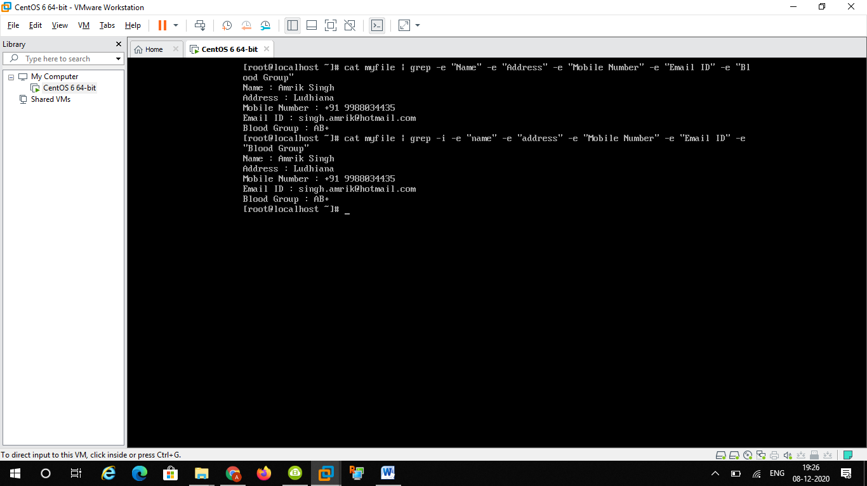

Below are few commands to get output in single line

Echo $(cat myfile) and the output is as below

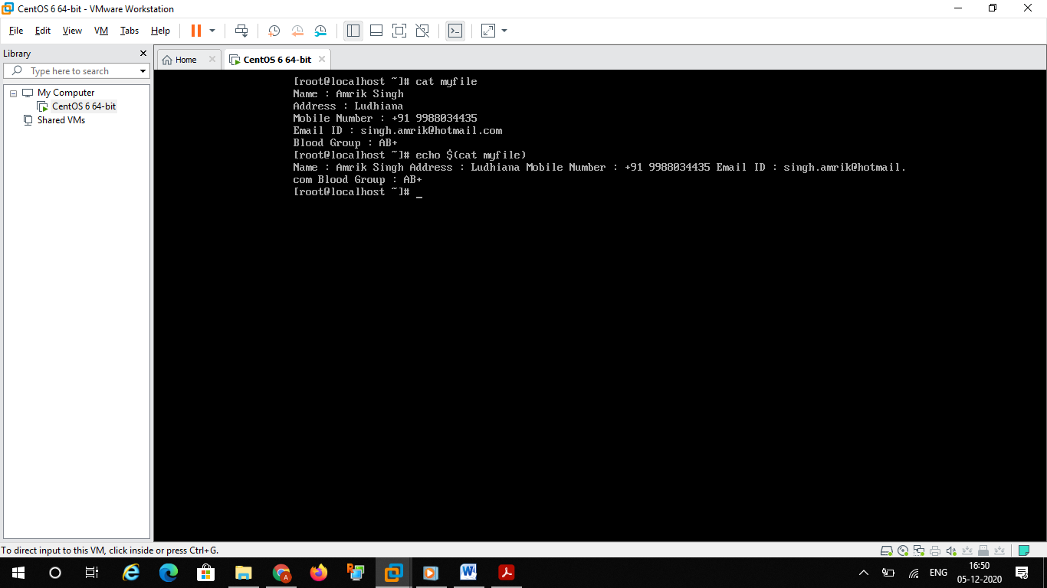

Then the second command which I tried is

Cat myfile | xargs

Output is as below

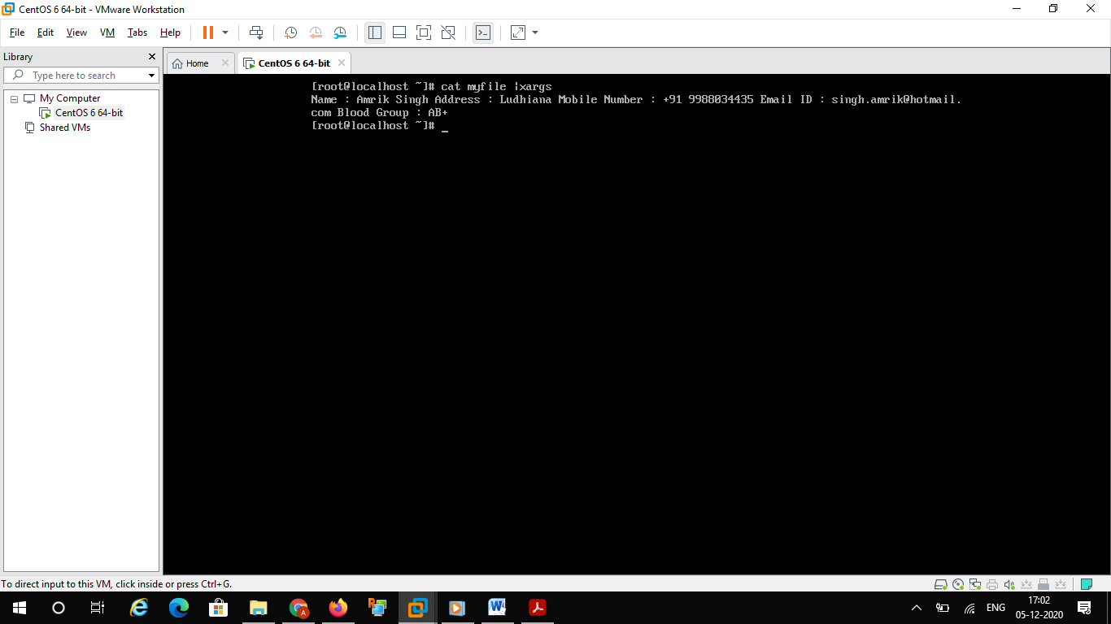

Another method tried

Paste command

Paste –d ,-s myfile

